國立臺北科技大學系所自聘
「全英語授課課程勞僱型兼任助理」申請表
Application Form for EMI TA Recruitment
年Year/ 月Month/ 日Day
用人單位  Employing Unit |  |  | 工程 學院 分子 系所  Department/Institution of Molecular Science and Engineering, College of Engineering
僱用別  Employment |  |  | □新First-time Recruitment |  |  |  |  |  | □續僱Continuous Recruitment
基本資料Personal Data | 姓名  Name | 金賀賈 |  |  | 身分證字號  ARC No. | MV225486996 |  |  |  | 聯絡電話  Cellphone Number |  |  | 28825252
基本資料Personal Data | 學號/系級  Student ID | 311059902  土木三甲 |  |  | 電子信箱  Email | A12345@gmail.com
基本資料Personal Data | 通訊地址  Residential Address | 女宿903
基本資料Personal Data | 出生年月日  Date of birth | 1983/08/04 |  |  | 國籍  Nationality | AUS |  | 非本國籍生是否持有工作許可證Work permit |  | □是，效期:  Yes，date of expiry:2
□否(須先申請)
None (Indispensable!)
基本資料Personal Data | 英語程度  English proficiency | CEFR B2 |  |  | 英語測驗分數  Score | TOEIC 850 、 IELTS 7 (overall)
基本資料Personal Data | 空堂時間  (TA培訓課程) | 110-2 Semester Available time slots (For TA training sessions)  每週二下午3:00-5:00 / 每周六上午9:00-12:00
課程資訊Course Info | 課程名稱  Course Name | 工程數學 |  |  | 課號  Course Number |  | 283218 | 學期  Semester |  | 110-2 | 授課教師  Instructor |  |  | 陳淑華
課程資訊Course Info | 學分數  Credits | 3 |  |  | 授課時間  Schedule |  | 每週三15:00-18:00 (共18週54小時)
課程資訊Course Info | 課程類別Course Type | 專業必修Required  專業選修Elective
課程資訊Course Info | 新開課程  New Course | 是Yes  否No |  | 開課班級  Class |  |  | 分子二甲 | 人數限制  The upper limit of the number of students |  |  |  | 75
課程概述  Course Description |  | 課程強調數學模式建立與動態系統的分析；透過簡單數學模式與重要生命科學實用例子說明1)控制方程式的建立；2)解與分析；3)數值模擬；4)科學銓釋等四個建模過程。分析重視多尺度、正負回饋以及穩定度問題，模式例子包含族群成長、掠食與被掠食交互作用、年齡結構、演替過程、行為模式、賽局理論、分子演化、渾沌系統、空間擴散模式等領域。課程也將強調重要數學觀念，並介紹因次分析與尺度分析於科學研究的應用。課程先需為略知微積分知識。  This course is designed to introduce you to the various topics and issues in the scientific exploration of psychology. Along the way, you will acquire basic knowledge of the influential theories and relevant research involving important aspects of psychology. You will discover what psychologists have learned that can enrich your studies, your relationships, your health, and other important aspects of your life.
兼任助理TA  (簽名欄) (Sign) |  | 工作內容Duties：  - 向老師要教材上傳北科i-學園 Upload course materials to NTUT i-Study.  - 管理課程line群組 Manage LINE class group.  - 算成績、收發作業 Assignment correction, grade calculation.  - 教具器材準備、架設與操作(有需要的話)  Preparation, erection, and operation of teaching aids (if applicable).  - 協助老師備課、課程紀錄  Assist instructors in preparing courses and teaching.  - 協助側錄課堂師生互動，並提供給學院。  Record instructors-students’ interactions and lecture clips, and submit them to the college of engineering.  - 每週利用Teams進行1-3hr輔導諮詢，錄影留存後提供給學院。  Provide weekly tutorial sessions (1-3 hrs/week), record tutoring sessions and submit to the college of engineering.  - 提供特色教學文件給學院。Submit featured course materials to the college of engineering.  - 其他教師/學院指定事務Others required by instructors or college of engineering.  簽名Signature:
授課教師Instructor  (簽名欄) (Sign) |  | 助教英語程度若未達B2，請填推薦理由  Please specify why you recommend this student whose English proficiency has not reached CEFR B2 yet  簽名Signature:

承辦流程  Approval Procedure |  | 承辦意見  Approval Notice
系承辦人  Contact Person  of the Department | 林淑貞(蓋章) | 林淑貞 OK
系所用人單 位 主 管  The Chair  of the Department | 郭霽慶(蓋章) | 郭霽慶 閱
院承辦人  Contact Person  of the College | 羅巧如(蓋章) | 羅巧如 OK
院長(決行)  The Dean  of the College | 陳貞光(蓋章) | 陳貞光 可

學生證件資料黏貼表 Form for Copies of Personal Document
電話  Contact Number |  | □已繳畢註冊費 Tuition paid  □碩一生繳附最高學歷證明文件Diploma
Email | @gmail.com | □已繳畢註冊費 Tuition paid  □碩一生繳附最高學歷證明文件Diploma
身份別 | 是否為原住民： □是 □否 | 身心障礙人士： □否 □輕 □中 □重度
身份證 正面影本(黏貼處)  Please stick the copy of  front side of ID card here |  | 身份證 反面影本(黏貼處)  Please stick the copy of  back side of ID card here
健保卡 正面影本(黏貼處)  Please stick the copy of  front side of National Health Insurance card here |  | 健保卡反面影本(黏貼處)  Please stick the copy of  back side of National Health Insurance card here
學生證 正面影本 (黏貼處)  Please stick the copy of  front side of student ID card here |  | 學生證 反面影本 (黏貼處)  Please stick the copy of  back side of student ID card here
存摺 正面影本(黏貼處)
Please stick the copy of bankbook cover here
需提供文件Required documents:
□「全英語授課課程勞僱型兼任助理」申請表(內可填寫教師推薦理由)
Application Form for EMI TA Recruitment
□ 學生證件資料黏貼表
Form for Copies of Personal Document
- 英語能力證明 (Ex. GEPT, TOEIC, TOEFL, IELTS 成績單影本)
Proof of English proficiency (Ex. GEPT, TOEIC, TOEFL, IELTS copy of transcripts)
- 110-2學期在學證明(於第三教學大樓一樓聯合服務中心申請)
Certificate of Enrollment (Apply at the Joint Service Center on the 1st floor of the Third Teaching Building)
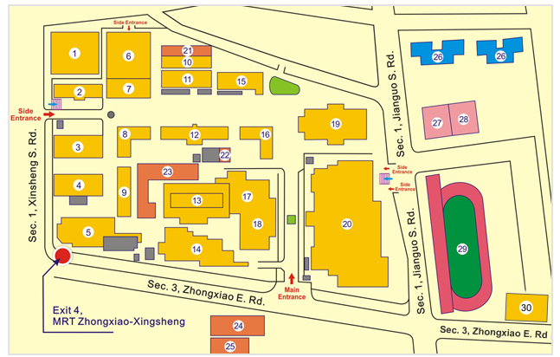
- 工作許可證明(僅外籍生須提供)
Work permit (Only required for foreign students)
※請參考國際處工作許可證申請辦法(https://oia.ntut.edu.tw/p/412-1032-9105.php?Lang=zh-tw)
※Reference: Apply for Work Permit (https://oia.ntut.edu.tw/p/412-1032-13812.php?Lang=en)

